One-Sample t-Test – Example 2 (Memory Booster)

A nutrition store in the mall is selling “Memory Booster,” which is a concoction of herbs and minerals that is intended to improve memory performance, but there is no good reason to think it couldn't possibly do the opposite. To test the effectiveness of the herbal mix, a researcher obtains a sample of 8 participants and asks each person to take the suggested dosage each day for 4 weeks. At the end of the 4-week period, each individual takes a standardized memory test. In the general population, the standardized test is known to have a mean of μ = 7.

Step 1. State your hypotheses.
a. Is it a one-tailed or two-tailed test?

b. Hypotheses in words
Alternative hypothesis:

Null hypothesis:

c. Statistical hypotheses
H_{A}:

H₀:

Step 2. Set the significance level ➔ α = .05 Determine t_{crit}. t_{crit} =

Step 3. Compute the appropriate statistical test.

Memory after taking Memory Booster (X) | 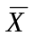 | Deviation  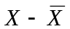 | 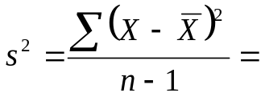Squared Deviation  () ²
8
9
6
8
9
8
7
9 |  |  | 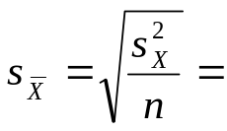
∑X =  N= |  |  | SS =  ∑ () ² =
=

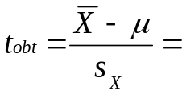

Step 4. Make a decision. Determine whether the value of the test statistic is in the critical region. Draw a picture. Label t_{crit} and t_{obt}.

Is t_{obt} in the critical region?

Should you reject or retain the H₀?

Step 5. Report the statistical results.

Step 6. Write a conclusion.

Step 7. Compute the estimated d.

Step 8. Compute r² and write a conclusion.

